Group Topic: Big Data Analysis for Rainfall-Based Flood Risk Prediction in Week 3
Albay using SYNOP Data

Git Repo/ Colab Link: https://github.com/PotatoKevz/Big-Data-Analysis- Date: May 2, 2026 Repository

Objectives
The main goal for this week was to identify the most suitable machine learning approach for predicting flood risk in Albay using SYNOP rainfall data. Specifically, the group aimed to:
- Choose the best algorithm among Prediction (Regression), Clustering, and Classification.
- Implement the selected algorithm in Python using actual meteorological data from Station 98444 (Legazpi, Albay) together with data from six nearby stations.
- Improve the model through fine-tuning to make the predictions more accurate and reliable for flood risk assessment.
Tasks Completed

Choosing an Algorithm

After evaluating the three approaches, the group decided to use Classification for the project. Three classification models were selected for testing and comparison.
The classifiers used were:
  - Random Forest Classifier – selected as the main model because it performs well on tabular datasets, handles missing values effectively through imputation, and provides feature importance rankings.
  - Gradient Boosting Classifier – used as a secondary model for comparison.
  - Logistic Regression – included as the baseline linear model.

Implementation of the Algorithm in Code

The implementation was organized into a structured Python pipeline named
flood_risk_predictor.py with the following stages:

  - Data Loading – All CSV files from the clean_dataset/ folder were loaded and parsed. Datetime columns were standardized, numeric values were converted properly, and each dataset was assigned to its corresponding station ID.
  - Feature Engineering – For Station 98444 (Albay/Legazpi), the script generated rolling rainfall windows for 12-hour, 24-hour, and 48-hour intervals. Lagged rainfall features using 3-hour, 6-hour, and 12-hour lookback periods were also added together with pressure tendency columns.

The six supporting stations also contributed their own rainfall and pressure features so the model could learn upstream weather patterns from each location.
  - Label Generation – Flood risk labels were assigned using a four-class system based on 24-hour accumulated rainfall thresholds aligned with DOST-PAGASA standards: LOW (<15 mm), MODERATE (15–50 mm), HIGH (50–100 mm), and EXTREME (>100 mm).
  - Model Training – The dataset was split into 80% training and 20% testing using stratification across all risk classes. Pipelines were built using scikit-learn with median imputation and standard scaling when necessary. The models were evaluated using Accuracy, Weighted F1 Score, Precision, Recall, and AUC-OvR. A 5-fold cross-validation was also applied to the Random Forest model.
  - Outlier / Extreme Event Detection – A separate module was created to detect extreme rainfall events using IQR fencing (Q3 + 1.5 × IQR) and Z-score thresholding (|z| > 3.0). Detected events were further grouped into “extreme” and “catastrophic” categories.

Fine-Tuning the Algorithm

Several adjustments were made to improve the model’s performance and solve issues encountered during the initial testing stage.
  - Class Imbalance – Since LOW-risk observations heavily dominated the dataset, the Random Forest and Logistic Regression models were configured with class_weight='balanced'. This prevented the models from predicting LOW risk for nearly all observations.
  - Hyperparameter Adjustments – The Random Forest model was configured with 200 trees, a maximum depth of 12, and min_samples_leaf=5 to reduce overfitting. The Gradient Boosting model used a learning rate of 0.1, 100 estimators, and a maximum depth of 5.
  - Feature Expansion – Instead of relying only on Albay station data, rolling rainfall features from all six supporting stations were added. This helped the model capture directional weather signals such as incoming typhoon activity from nearby areas like Catanduanes.
  - Validation – A 5-fold cross-validation process was added to the Random Forest model to evaluate how well the model generalizes beyond a single train-test split.

Tasks to be Completed
The group plans to complete the additional tasks that will be assigned in the following week.
Results and Analysis

The pipeline was executed using the complete cleaned dataset covering all seven SYNOP stations from 2000 to 2026. The primary station, 98444 (Albay/Legazpi), contributed 76,544 records. The six supporting stations also provided additional context: Camarines Norte (98440) with 76,899 records, Catanduanes (98446) with 76,283, Infanta (98434) with 75,647, Masbate
(98543) with 75,956, Romblon (98536) with 73,888, and Tayabas (98427) with 75,034 records.
Rainfall, pressure, and humidity readings from the supporting stations were integrated into the model as separate features alongside the Albay station data. For the primary station, the final risk distribution consisted of 51,057 LOW, 15,877 MODERATE, 6,140 HIGH, and 3,470 EXTREME

observations. This confirmed the class imbalance issue that required balanced weighting during fine-tuning.
  - All three models performed very well. Gradient Boosting achieved the best performance with 99.97% accuracy and a perfect 1.000 AUC score. Random Forest followed closely with 99.94% accuracy and a 0.9999 AUC score. Logistic Regression also performed well with 98.32% accuracy, although it was noticeably lower than the tree-based models. The confusion matrix for Random Forest showed near-perfect classification across all four risk levels, correctly predicting 10,203 LOW, 3,175 MODERATE, 1,228 HIGH, and 694 EXTREME observations with almost no misclassifications.
  - Feature importance analysis from the Random Forest model showed that rain_24h was the strongest predictor with an importance score of 0.4530, followed by rain_48h at 0.1785 and rain_12h at 0.1043. The supporting stations also contributed meaningful signals. Catanduanes (98446) had the strongest contribution among them with rain24h_98446 at 0.0311 and rain12h_98446 at 0.0118, showing its value as an upstream typhoon indicator. Camarines Norte (98440) followed with 0.0199, while Masbate (98543) contributed 0.0183. Romblon (98536) and Tayabas (98427) also contributed smaller but still noticeable signals at 0.0078 and 0.0073 respectively. These results confirmed that the multi-station approach was effective because the model learned from regional rainfall patterns rather than depending only on local Albay readings.
  - The outlier detection module identified 17,026 extreme rainfall events throughout the dataset. The timeline revealed recurring extreme events across the 2000–2026 period, with the highest spikes reaching almost 1,000 mm within a 3-hour window around 2019–2020. The Z-score visualization also showed several catastrophic outliers far above the 3-sigma threshold, with the highest recorded Z-score exceeding 70.
  - The final risk distribution showed that LOW-risk conditions represented 66.7% of all observations, followed by MODERATE at 20.7%, HIGH at 8.0%, and EXTREME at 4.5%. The year-by-month heatmap also showed that flood risk becomes more severe during typhoon season, especially from August to November. Some years such as 2005 and 2008 displayed longer and more intense high-risk periods compared to others.

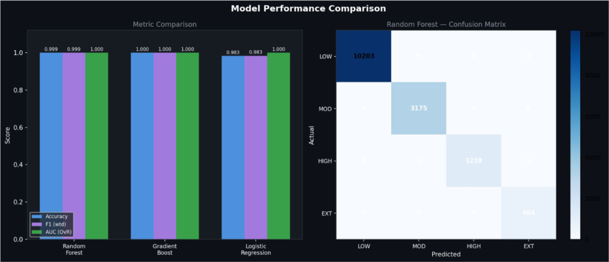



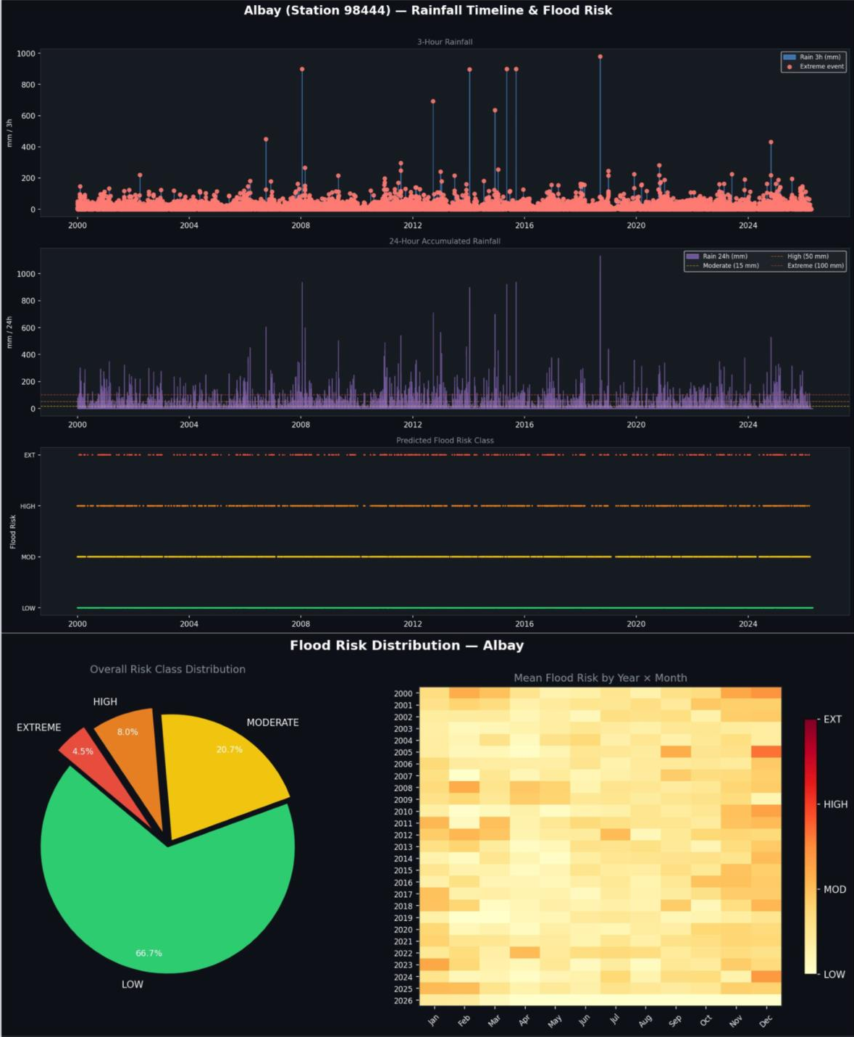

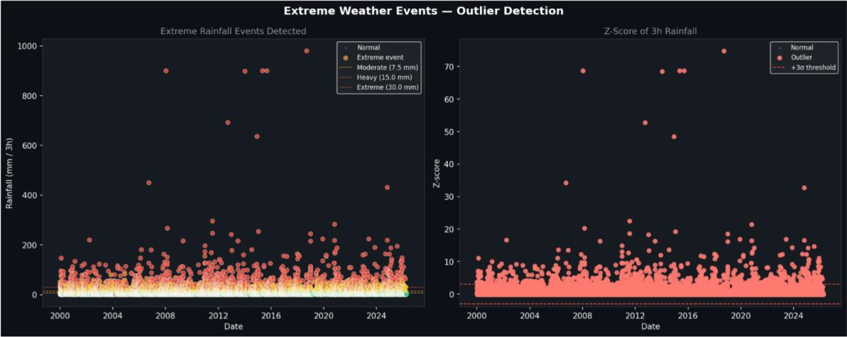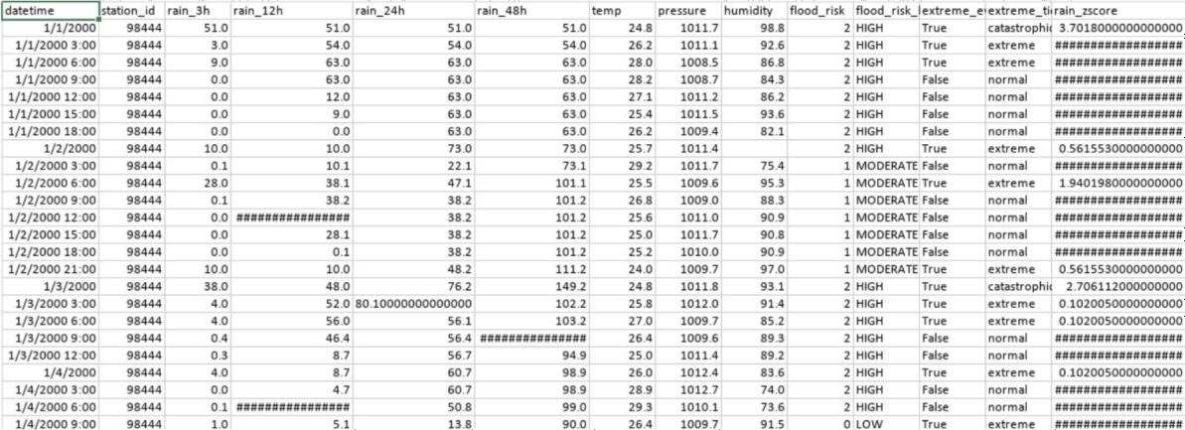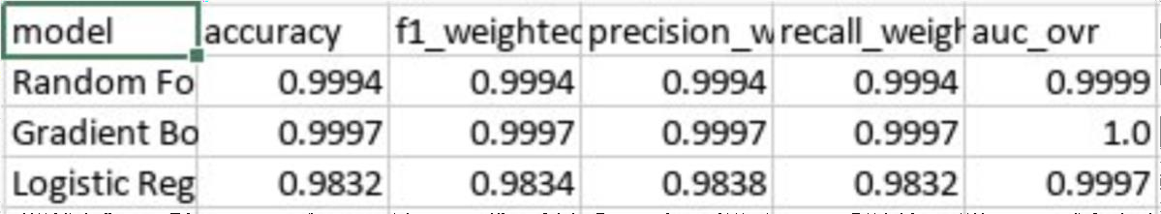

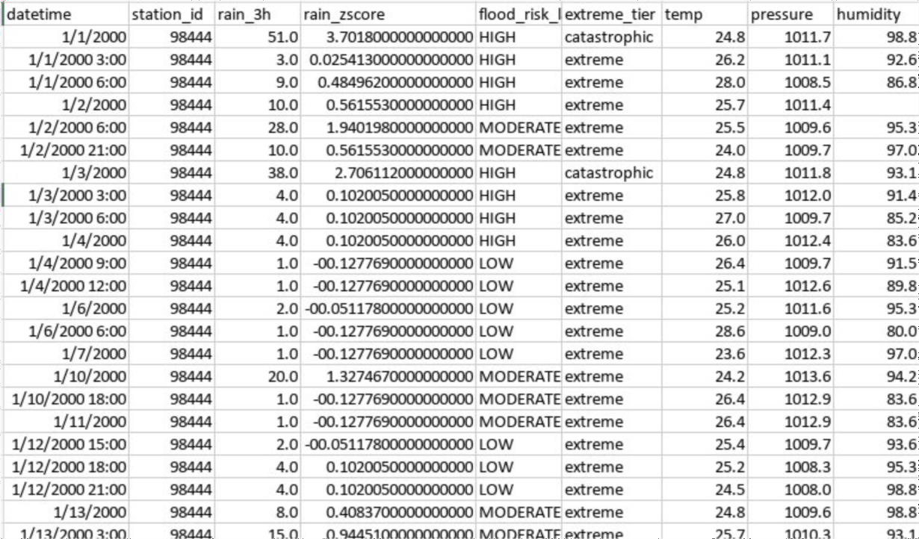

Challenges and Solutions

Challenge 1: Class Imbalance in the Risk Labels

During the initial runs, the model kept predicting LOW risk for almost every observation while still producing high accuracy scores. The group realized that this happened because most records in the dataset naturally belonged to the LOW-risk category.
Solution: The group applied class_weight='balanced' to both the Random Forest and Logistic Regression models so that minority classes such as HIGH and EXTREME would receive greater importance during training. stratify=y was also added to the train_test_split function to ensure that all risk classes were proportionally represented in both the training and testing datasets.

Challenge 2: Aligning Multiple Station Timestamps

The supporting stations did not always have matching timestamps with the main Albay station. Directly merging the datasets resulted in many NaN values and misaligned rows, which affected the rolling window calculations.
Solution: In the engineer_features function, each supporting station dataset was resampled into a consistent 3-hour interval using .resample('3h').mean(). The datasets were then re-indexed to match the datetime index of the Albay station. This ensured proper alignment before applying rolling and lag operations.

Challenge 3: Feature Matrix Becoming Too Large

After adding rainfall, pressure, and humidity features from all six supporting stations, the feature matrix became significantly larger. The group became concerned that this could slow down training or lead to overfitting.
Solution: The Random Forest parameters max_depth=12 and min_samples_leaf=5 helped limit model complexity despite the expanded feature set. Feature importance analysis was also used to confirm that the model was not relying on irrelevant variables. In addition, the 5-fold cross-validation results showed that the model generalized well instead of memorizing the training data.
Conclusion

The Week 3 implementation of the Big Data Analysis for Rainfall-Based Flood Risk Prediction project successfully demonstrated the effectiveness of a multi-station, classification-based machine learning approach for assessing flood risk in Albay. By selecting Random Forest Classifier as the primary mode, supported by Gradient Boosting and Logistic Regression, the group effectively addressed the core objective of identifying the most suitable algorithm among regression, clustering, and classification for this meteorological application.
The developed flood_risk_predictor.py pipeline delivered exceptional performance. The models achieved near-perfect results on the 2000–2026 SYNOP dataset from Station 98444 (Legazpi) and six supporting stations. Gradient Boosting reached 99.97% accuracy with a perfect 1.000 AUC-OVR score, while Random Forest closely followed with 99.94% accuracy and 0.9999 AUC. These high metrics, validated through stratified train-test splits and 5-fold cross-validation, confirm the robustness of the approach even with class imbalance.
Key innovations that drove these results include:
Comprehensive feature engineering with rolling rainfall windows (12h/24h/48h), lagged features, and pressure tendencies.
Integration of upstream signals from neighboring stations (particularly Catanduanes), which enriched the model’s understanding of regional weather patterns.
Targeted handling of challenges such as timestamp alignment (via 3-hour resampling), class imbalance (via class_weight='balanced' and stratification), and large feature sets (controlled by tree depth and leaf constraints).
The feature importance analysis validated the approach: 24-hour rainfall emerged as the dominant predictor, while supporting stations provided meaningful additional context for incoming weather systems. The outlier detection module further added value by flagging extreme and catastrophic rainfall events, revealing historical patterns consistent with Albay’s typhoon vulnerability.
This project confirms that SYNOP data, when properly engineered and modeled with ensemble tree-based classifiers, can provide highly reliable four-class flood risk predictions (LOW, MODERATE, HIGH, EXTREME) aligned with DOST-PAGASA thresholds. The system offers strong potential for practical early warning applications in the Bicol Region.
Moving forward, the group is well-positioned to build on this foundation. Future work can focus on real-time deployment, integration with additional data sources (e.g., satellite or radar), model explainability enhancements, and operational testing during the next typhoon season. Overall, Week 3 represents a significant and successful milestone in developing data-driven flood resilience tools for Albay.

